Heat Transfer: 热能传播所遵循的规律

1. Basic Introduction
   1. Diffusion equation: to determine Tempreture function
      1. Thermal Diffusivity
   2. Thermal resistance, 使用热阻法时，两端温度相同的传热为并联，两端温度不同的为串联
      1. Conduction
      2. Convection
      3. Radiation
   3. Boundary Condition (P83)
      1. First Boundary Condition/Dirichlet Condition: constant surface Temperature
      2. Second Boundary Condition: Constant surface heat flux
         1. Finite heat flux
         2. Adiabatic or insulated surface
      3. Third Boundary Condition
2. Conduction: Diffusion of energy due to random molecular motion
   1. Steady State: Fourier’s law
      1. General heat equation (derived from energy balance equation):
      2. 1-D Steady State
         1. Steady State general solution
            1. Plan wall

Without heat generation

With heat generation

* + - * 1. Cylindrical

Without heat generation

With heat generation

* + - * 1. Sphere

Without heat generation

With heat generation

* + 1. Multi-dimensional Steady State
       1. Analytic method: Separation of variables 分离变量
       2. Numerical method: Finite difference method 有限差分法
    2. Fin 肋片
       1. General solution of energy equation If Ac & P are constants, dAc/dx=0, enegy equation will become
       2. General Solution of temperature distribution
       3. Fin Effectiveness and Fin Resistance
  1. Transient Conduction
     1. Analysis method
        1. Analytic method
           1. 分离变量
           2. 积分变换，拉普拉斯变换
        2. Approximation method
           1. Lumped capacitance method 集总热方法
        3. Numerical method
           1. Finite difference method 有限差分方法
     2. Biot number and Fourier number: dimensionless number 无量纲量，当所研究的现象非常复杂，涉及到非常多的参数时，为了减少涉及到的量纲数量简化运算，把一些列的量纲组合起来以使之能表示特定的物理现象或者主要特征，且没有量纲。又称为特征数，特征数涉及到的几何尺度又称为特征长度l。
        1. Biot number : dimensionless thermal resistance, 与物体形状有关
        2. Fourier number : dimensionless time
     3. Lumped capacitance method
        1. Total energy transfer:
        2. Radiation only
        3. Negligible Radiation
        4. Convection Only with variable convection coefficient
     4. , use analytic solution
        1. exact solution, applies to any time of and
           1. Plan wall
           2. Radial systems with convection

Infinite cylinder

Sphere

* + - 1. approximation solution can be achieved by using the first term of the infinite series number ,
         1. Radial systems with convection

Infinite cylinder

Sphere

* + - 1. Total energy transfer, approximation solution:h
      2. Semi-Infinite solid
    1. Muti-dimensional problems solving with Finite-Difference methods
       1. The Explicit Method 古典显格式
       2. The Implicit Method 古典隐格式
  1. 处理瞬时传热问题的思路*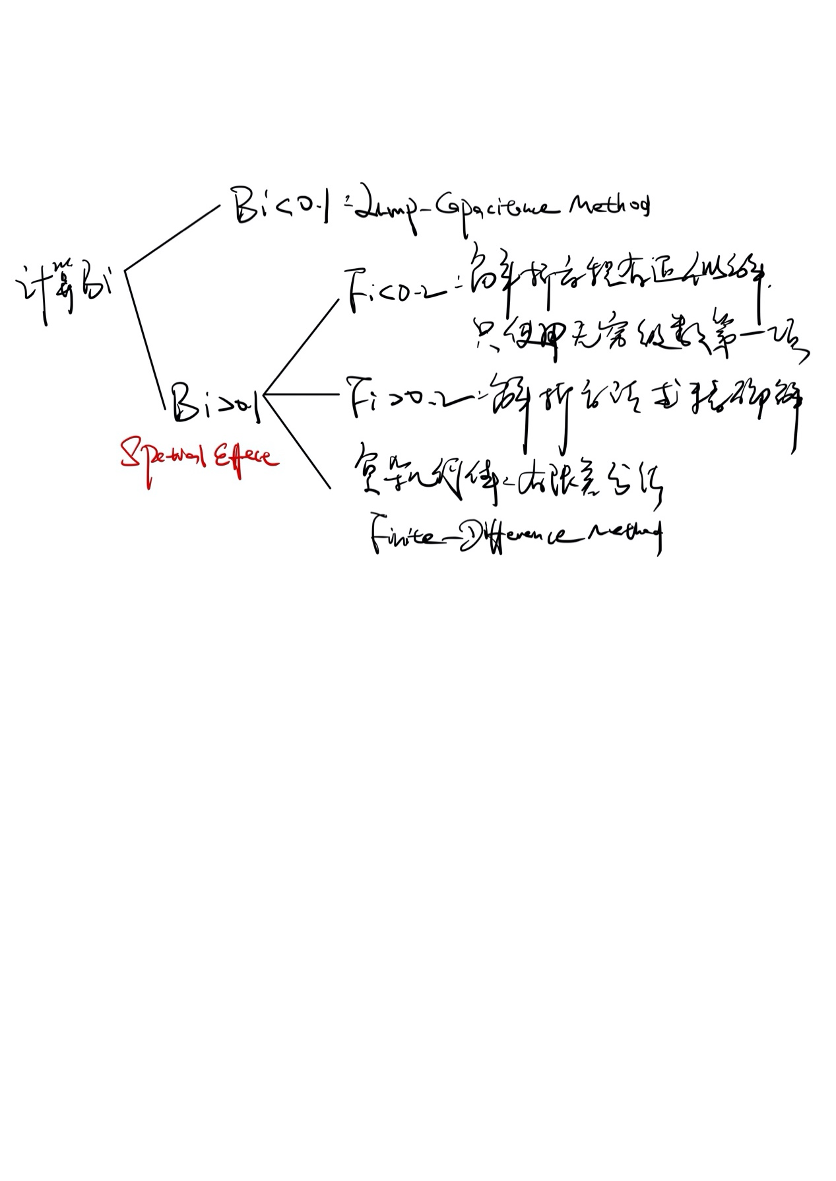*

1. Convection: Diffusion of energy & transfer due to advection
   1. Boundary layer 边界层
      1. Velocity Boundary Layer: Surface friction
      2. Thermal Boundary Layer: Convection heat transfer
      3. Concentration Boundary Layer: Convection mass transfer
         1. Fick’s Law
         2. Advection (can be neglected)
      4. Boundry Layer relationship

         2. Heat&Mass Transfer analogy
   2. External Flow
      1. The Emprical/Experimenatl method, using Non-dimensional analysis
         1. Emprical correlation:Heat transfer correlation (Constant fluid properties is implicit); Mass transfer correlation: . Evaluate at a mean boundary layer Temperature
            1. For Laminar flow

Local Nusselt number

Average Nusselt number

Local Sherwood number.

Average Sherwood number

* + - * 1. For Turbulant flow

* + - * 1. Mixed Boundary Layer Conditions

* + - 1. Methodology of convection calculation
         1. Justify which geometry you are dealing with.
         2. Set refrence Temperature and get fluid properties according to film Temp in table A-4物体的表面有流体对流而产生的边界层，边界层问题主要是求对流系数，进而求得热流。因为热流系数是通过解边界层的各种无量纲方程得出的，因此需要边界层中流体的性质，边界层中因为有温度变化不能求的准确值，所以用平均温度来变化。
         3. Find Reynold number to determine whether it’s laminar of turbulence.
         4. Decide if you need h or . H is used for constant surface temperature or vapor density to determine local coefficient of one particular point. is used to determine heat transfer rate for the entire surface.
         5. Find a correlation and solve.
      2. The Cylinder in Cross Flow (P424)
      3. Sphere (P431)
      4. Flows across banks of tubes
    1. The Theoretical method
  1. Internal Flow
     1. Strategy 先确定是指需要考虑thermal boundary layer（例如油和Pr>5）还是需要同时考虑thermal boundary layer和hydrodynamic boundary layer，然后计算确定Fully developed还是Entry region，再计算Re#确定Lam or Turb^
     2. Boundary layer
        1. Hydrodynamic boundary layer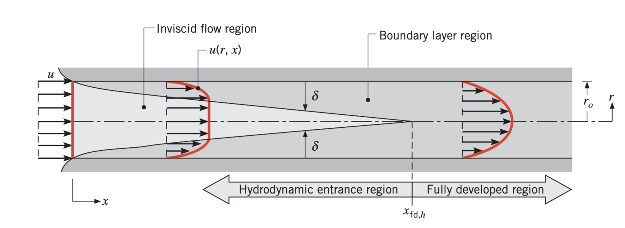
           1. Transition condition:
           2. Hydrodynamic entry lenth

Laminar

Turbulence

* + - * 1. The mean velocity & Reynolds# with mass flow rate (for pipes)
        2. Pressure gradient and friction factor in fully developed flow
      1. Thermal boundary layer, 重要特性，h在entry最大，在fully developed region为常数。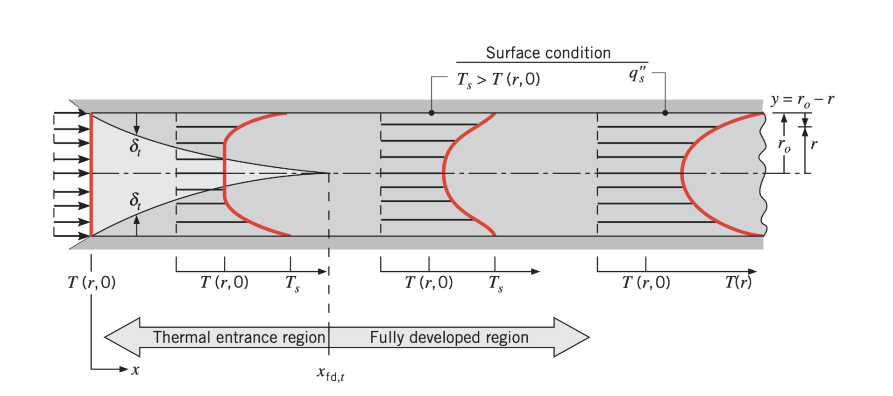
         1. Entrey length
         2. The mean temperature
    1. Energy Balance ，在计算能量时，需要用到进出温度的平均值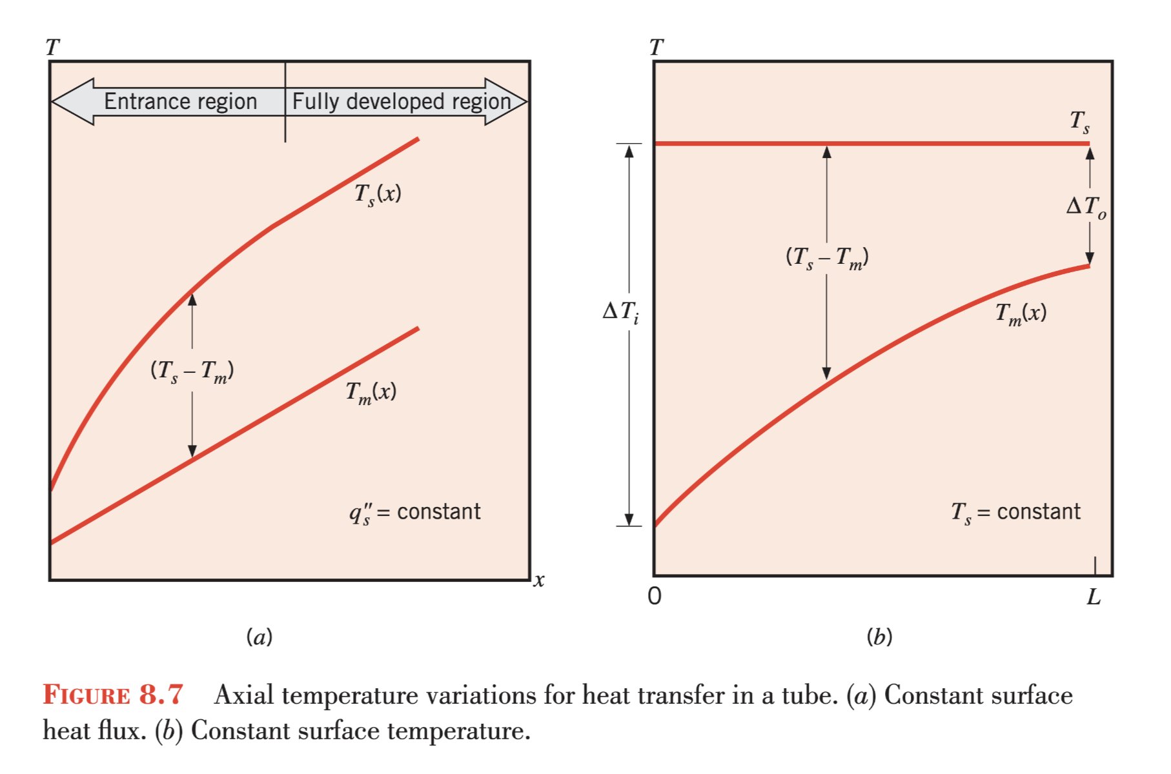
       1. Constant surface heat flux
       2. Constant surface temperature
    2. Convection coefficient determination，在处理internal flow时，不需要计算film temperature,直接使用进出口温度
       1. Fully developed region
          1. Laminar

Constant surface heat flux

Constant surface temperatur

* + - * 1. Turbulence
      1. The entry region
         1. Thermal entry length (Engine Oil)
         2. Combined entry,除了engine oil 都用该式
      2. Combined entry
  1. Free Convection (Chapter 9)
     1. Physcial considerations: In heat transfer, buoyancy is arising due to density gradient (which is caused by Temperature gradient) and gravitational body force.
     2. Distinguish characteristic of Free convection & forced convection: The ratio between 图片包含 屏幕截图

        描述已自动生成
     3. Governing equation
        1. Detemination: (P559)
        2. Laminar
        3. Turbulent
     4. Empirical correlations: external free convection flows
        1. Vertical plate
        2. Inclined and horizontal plates
        3. The long horizontal cylinder
        4. Spheres

1. Radiation: Energy transfer by electromagnetic waves
   1. Overview图片包含 文字, 地图

      描述已自动生成图片包含 屏幕截图, 文字

      描述已自动生成
   2. Important assumptions
      1. Diffuser: surface properties are independent of direction
      2. Blackbody
         1. Definition
            1. A diffuse emitter (Intensity is independent of direction)
            2. No surface can emit more energy than a blackbody
            3. Absorbs all incident radiation of all wavelength&direction (No reflection)
         2. The Planck distribution
            1. The Stefan-Boltzman Law
         3. Wien’s displacement law 维恩位移定律 图片包含 文字, 地图

            描述已自动生成物体会向外辐射出所有波长的波(0-无穷)，只是各个波段的波的占比度不同。颜色不同也是因为各个波长成分的光所做出的贡献不同。比如在宇宙中，温度较高的天体为蓝色，其次为白色（不同波段的波分布比较均匀），温度较低的为红色。人体的温度较低，故只能辐射处在可见光范围之外的红外线。（可见光光波从长到短：红橙黄绿青蓝紫）
      3. Greybody
         1. Kirchhoff’s law
         2. Grey surface: surface properties are independent of wavelength
   3. View factor(多个表面)
      1. Definition for : The fraction of the radiaition leaving surface I that is intercepted by surface j. . View Factor仅仅是一个几何关系，从定义中可以看出Radiosity被消除了，与温度等热力性质无关。
      2. View factor relation
         1. Reciprocity relation
         2. Summation law
         3. 结合律（自创）
      3. Radiation network approach 图片包含 文字, 地图

         描述已自动生成
         1. Surface radiative resistance:
         2. Network elements
            1. Geometrical resistance
            2. Driving potential
      4. Direct formula approach (Nodes>=4, because then the net becomes too complicated)
      5. Symmetry & Hypothecial surface图片包含 文字

         描述已自动生成
   4. Multimode heat transfer
   5. Enclosure radiation
      1. Enclosure of black surfaces
      2. Two-surface enclosure
         1. Radiation shield (Series)
      3. Three-surface enclosure with a reradiating surface
         1. Reradiating surface , Negligibel external heating&Conv